Analysis stage

Introduction

In chapter 1 of decision mathematics 2 in edexcel, students will learn and be able to solve transportation problems in different situations. For example: there are balanced and unbalanced problems that need to be dealt with differently to each other. The solution of the question is the optimal solution, which is the smallest amount to pay to deliver stock from multiple suppliers to multiple customers. This means that they will also learn the algorithms and methods associated with it. At some points, the whole process is repeated as the optimal solution has not be achieved.

The methods and algorithms can also be partly used as a “calculator” for companies to work out the minimum cost of delivering stock to multiple customers. This therefore increases the overall profit that the company makes.

There are two ways that the transportation can be represented: in a grid form, or in text. In grid form, it can show multiple information, like the delivery cost of each cell and the stock it will transfer, to the shadow costs and total supply and demand that each cell is affected by. In text form, it explains where an amount stock from a certain supplier will go to a certain customer.

There are also multiple methods to use to get to an optimal solution for the problem. the initial methods discussed in this project is the north-west corner method and the least-cost method. The least-cost method in general is finding the lowest delivery cost in a table, put as much stock as possible on that cell while not breaking the rules, and repeat. This leads to an optimal solution that is a bit easier than the other method.

The north-west corner method finds the initial solution for the problem by starting at the north-west corner of the gird, deal with stock and demand amount, and move in the direction where the supply or the demand or both is not at their limit. The initial solution then can be used to find the shadow costs, improvement indices and doing the stepping-stone method if necessary. This whole process is repeated until an optimal solution is found.

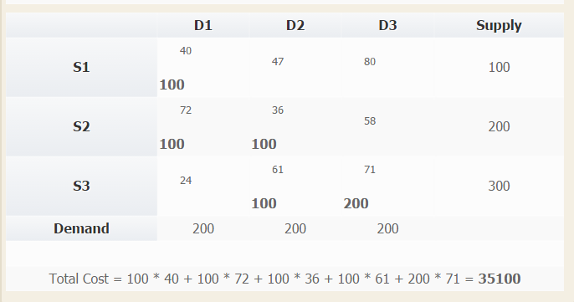

S1 will deliver 100 stock to D1

S2 will deliver 100 stock to D1

S2 will deliver 100 stock to D2

S3 will deliver 100 stock to D2

S3 will deliver 100 stock to D3

the picture and text above show the initial solution done by the north-west corner method in grid and text form.

The problem:

As the north-west corner method only gives the initial solution and other algorithms and methods are used, the whole process of finding the optimal solution is time-consuming and frustrating. The reason why is that a student could get wrong anywhere during the solving but, it’s very difficult to find (or even know that…) the solution that is correct at the time. This leads to students scraping their current solution and starting new, which is annoying.

Another reason is that for the teacher to explain the correct optimal solution to the students is a long process. In the text book that is currently used only show the optimal solution, but not the solutions at each iteration. So the teacher can’t quickly check that the students are correct at each stage.

Research

as part of the research, I examined websites, methods and instructions on how the problem can be solved. This will then be used to visualize an idea for the target prototype.

The test data being used is this:

|  |  |  |  |  |
| --- | --- | --- | --- | --- |
| unit cost | customer1 | customer2 | customer3 | total supply |
| supply 1 | 40 | 47 | 80 | 100 |
| supply 2 | 72 | 36 | 58 | 200 |
| supply 3 | 24 | 61 | 71 | 300 |
| total demand | 200 | 200 | 200 | 600 |

This makes it easier to compare the solution with the test data that is being used for the research.

First product: north-west corner method calculator1

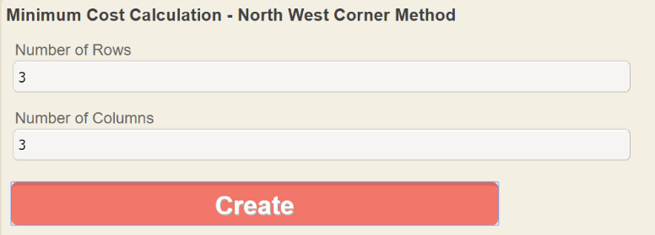The calculator on the website finds the initial solution by doing the north-west corner method. It first asks the user how many rows and columns does the problem have. In general, this means how many suppliers and demanders are involved with the problem. after clicking “create”, a gird is formed that allows you to enter delivery costs for each cell, including the total supply for each row and the total demand for each column. After the numbers are entered, and clicked “calculate”, It shows the solution in grid form, showing how much stock should go to each demander. It also shows and works out the total cost of the operation.

A snapshot entering the number of rows and columns

A snapshot of the initial solution of the test data.

Advantages:

* In terms of design and placement of the entry boxes, the appearance of the calculator is nice and easy to follow. It makes it simple and only requires the user to enter the required numbers.
* It does as it said. It works out the initial solution of the problem.
* The web-based utility is also free to use as well.

Disadvantages:

* In the terms of the showing of the initial solution, some people can be a little confused on which numbers are which if a student is just starting on the problem.
* Even through it’s a great calculator to show the result of the method, it does not show the individual steps to get to the solution. This makes it not useful for students who want to know how to do it.
* It only does the method and that’s it. Which means that the optimal solution has not been found.

Second product: the excel built-in solver2

The second way of doing this is using the solver in excel. First, the user has to create a structure that they understand. They also need to include the additional elements like the current total supply for each row and the same for the column. After the user inputs the numbers, another grid has to be created, that holds the solution to the problem, the user now starts the solver in excel. This opens the window and the user has to adapt the options and information so that it can find the optimal solution.

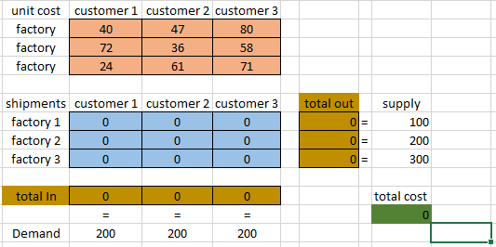

Before the solver

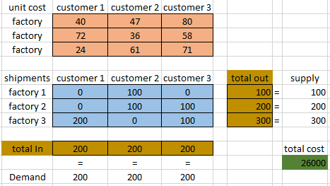

after the solver

Advantages:

* The software can be used without the internet, which is useful for students if they are going somewhere.
* It allows the student to get the optimal solution in grid form, which is useful in some cases when trying to get an answer quickly.

Disadvantages:

* In the end, this method is not suitable. The reason why is because it is not going through the various methods and algorithms that the book says to do, or at least what the students supposed to know.
* For students doing it the first time, it’s a very complicated process, even with the instructions. This is because an additional plug-in was needed to be installed to solve this. And after that, the correct values are needed to be entered correctly to get the optimal solution.
* For unbalanced problems, they cannot be solved, having a less useful purpose to students.

Third product: transportation problem solver3

The third product is a website that solves the transportation problem in multiple ways, including the north-west corner method. It allows the user to change the size of the grid, or even go through a different inputting situation using text and tabs to separate. After that, the student will be able to solve the problem using the NWCM. The solution is created, detailing how the solver got to the answer with each step.

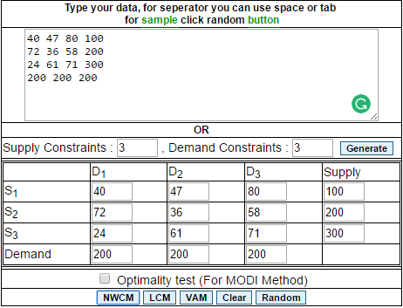

The data was entered at the top and it was placed into the grid automatically by pressing “generate”

Advantages:

* It solves the problem with an answer depending on the method used.
* This is the only product that shows the steps to solving the problem using the north-west corner method, which is incredibility useful to students to understand.
* This has the ability to import the “text” of a text file into a box, and be able to calculate the grid size and where each value goes, which is quick.
* It also adds a dummy if the values are unbalanced, which is also very useful.

Disadvantages:

* It does not continue to solve the problem, only doing the north-west corner method and that’s it. So it’s only use is to solve the problem using the first method.

Overall:

With the first product, it had the appearance and was able to calculate the north-west corner method, even allowing the user to change the size of the grid. but that’s it. It does not solve the problem if it is unbalanced, and does not show the steps to completing it. Making it little use to students.

The second product was the worst product out of the group. The only connection this has to students is finding the optimal solution of a problem. the only advantage about this is that it is offline, meaning it can be used anywhere.

The third product is by far the best. It allows the user to enter values by text or by a grid, that is also is adjustable. When the problem is solved using the method, it shows the exact steps on how to solve it and even adds the dummy, which is great for a problem like this.

1<https://www.easycalculation.com/operations-research/minimum-transportation-northwest-corner-method.php>

a

Third party

2 <http://www.excel-easy.com/examples/transportation-problem.html>

The end user that this will be look at is Mr. Murphy, a mathematics teacher that teaches decision mathematics by edexcel at collage. The interview is shown below:

**In a classroom environment, when you are given a transportation question with no answer, how do you deal with it?**

3 http://cbom.atozmath.com/CBOM/transportation.aspx

**As the transportation problems can get long and repetitive with harder questions, how do you keep track of the real answer?**

**Does it get a little annoying that everyone could be wrong at different sections of the whole problem, yet do not have a record of where they went wrong?**

**So if the program could not only give the optimal solution but also show the solution at each iteration, acting as kind of checkpoint, would that be useful in a class environment?**

**Do you think that having a program like this would be beneficial to not only the classroom but also the students for revision purposes?**

**In a program built to solve transportation problems, what can be done to make it easier for users to know what they are doing, for example like the appearance of entering numbers?**

**Do you find it difficult to create randomly generated transportation problems?**

**If so, would a program generating theses’ values are useful in the classroom and when preparing homework?**

Objectives

These objectives are the main points of the program:

1. Create a graphical user interface(GUI) that lets the user be able to do what they want to do.
   1. The interface will include spaces for the user to enter their amount of rows and columns and a create button
   2. The create button will create a grid where the user can then enter the numbers. The values placed in will be checked if the values are in range and are intergers so that an error does not occur, crashing the system.
2. Create a grid-like window that allows the user to enter the delivery cost of each cell and use the options if the user wants to see iterations of the problem or not.
   1. The options will affect the excel file if the user wants to export the solution, as it might include iterations for use of the student.
   2. The grid will be made of small writable blocks that are arranged in a grid. This also means that as the rows and columns will always be different, a certain number of these will be created depending on the user.
   3. The total supply and total demand will be checked to see if the problem can be done. If the demand is more than the supply, then it will give a warning about it.
3. To be able to program the various methods and algorithms to deal with the problem to give the optimal solution, and no matter the problem, the program will go through the problem again and again until it reaches the final solution.
   1. Before the values can be used to solve the problem, the values will be checked to see if they are integers and do not contain any letters
   2. The values will go through the methods:
      * North-west corner method
      * Shadow costs
      * improvement indices
      * entering cells
      * stepping stone method

the values will be repeated until an optimal solution is found.

1. Shows the optimal solution both visually, and written and allows the user to export the excel file if needed.
   1. This will be shown in a grid form so the user understands the solution. This will have the final cost.
   2. For the solution to be written, it will need to have a “template” sentence to put in the supplier, destination and how much is being transported. for example: “(supply) Will send (stock amount) stock to (demand). Cost is (delivering cost x stock)” This will also have the final cost, and individual cost for each delivery.
   3. The window will include buttons if the user wants to export the solutions and/not into an excel file.
2. Allow the user to use the program again, resetting everything to default.

These are the optimal parts of the program:

1. Allow the user to get a random transportation question.
   1. Add a “random” button into the main menu that allows the user to create a transportation question using the rows and columns stated by the user.
      1. The rows and columns will create a grid, making it easier to program ahead and less likely for the user to make a mistake if copying a question from a source.
   2. Be able to create a visual grid showing the placement of delivery cost of each cell, and the total supply in and out.
      1. In the window will be the grid, a button for the solution, a button to randomise again and an option if the iterations should be in the excel file if needed.
      2. To reduce the chance of getting a badly constructed question, the program will check if the total supply is equal or more than the total demand. If not, make the program randomly chose more numbers to replace.
      3. What could be done is to add difficulty options that let the user decide if the problem is unbalanced or not.
   3. by pressing the “solution” button, the program will solve its own problem, giving the optimal solution and request if the user wants to export the solution and its iterations.

acceptable limitations:

* the size of the grid will be between the smallest size: 3x3 to the biggest size: 10x10. The reason why for this is that if the size of the grid is too large, the grid might bug out in the size of the window, and the same case with the grid being too small.

Data storage

The program will hold data in the RAM. But if the user wants to export the optimal solution and its iterations, then an excel sheet will be used to copy and paste the solution at each iteration including the optimal solution and the original question into a excel file, so that the user can amend the results.